**Interactive Model Performance and Explainability (IMPEx)**

The Interactive Model Performance and Explainability (IMPEx) system is specifically designed to enhance machine learning interactions through course-based academic case studies. It utilized two distinct time series datasets: the Assessment Dataset, which includes information on 3,720 Computer Science undergraduates at a public university, and the Learning Management System (LMS) Dataset, comprising detailed access logs from the Universiti Putra Malaysia's LMS platform, PutraBLAST.

IMPEx is built on an advanced deep time series model, specifically an enhanced Long Short-Term Memory (eLSTM) model, which facilitates Explainable Deep Time Series Analysis to provide transparent educational insights. The system operates through three main stages:

* **Model Monitoring:** This stage involves continuous tracking and evaluation of model performance. Users can select a semester to analyze course metrics, distinguishing between courses with accuracy above and below a 60% threshold as determined by the eLSTM model. Courses with low accuracy are identified for further analysis using SHAP and LIME for model interpretation and debugging. Also, it gives this ability to redevelop models by adjusting hyperparameters such as epochs, sequence length, learning rate, and batch size, with updated SHAP and LIME results available for download.
* **Insight Generation:** This stage provides detailed analysis of course and student performance. It includes a Course Performance Dashboard that displays metrics like participation and accuracy, and student performance details featuring tables with actual versus predicted grades and recommendations based on Euclidean distance.
* **Reporting:** This stage generates comprehensive summaries, including a list of courses requiring redevelopment due to low average accuracy and a complete list of courses with accuracy below 60% across all semesters.

This systematic approach ensures a robust, data-driven analysis that enhances educational outcomes through transparent and actionable insights. Fig. 1 illustrates the architecture of the IMPEx system.

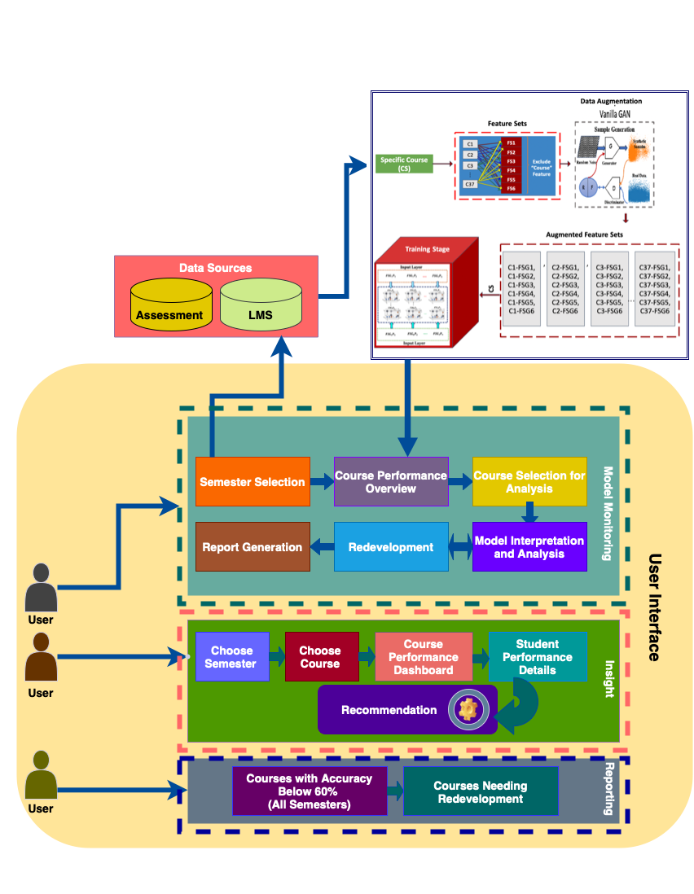

**Fig.1** IMPEx System diagram.